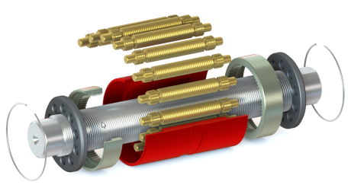
APPLICATION DATA LIST FOR ROLLER SCREWS

DATE :__________________
CUSTOMER INFO
Company Name :____________________ |  | Address :_____________________________________
Contact Name :________________ | Phone :_____________ |  | Email :________________________

APPLICATION/ INDUSTRY :_______________________________________
Drawing attached : ☐ Yes Drawing Number :___________________________ ☐ No
New Application: ☐ Yes ☐ No | Name of the Project:_______________________
□ New Screw ☐ Existing Screw | Screw Size / Ref Number:___________________

OPERATING CONDITIONS (Please specify units)
Number of screws supporting the load:_____
Maximum Load: Static:______________ |  |  | Dynamic:_________________
Typical Load Chart (function of the stroke, forward and reverse stroke)
Stroke
Load
0

Typical Speed Chart (function of the stroke, forward and reverse stroke)
Stroke
Speed
0

Useful Stroke:___________________________ |  |  | Max Stroke:______________________________
Alternatively please fill-in the chart below and specify units:
 | Load | Speed | Time | Stroke | Remarks
Step 1
Step 2
Step 3
Step 4
Step 5
…

Main Load : ☐ Compression ☐ Tension
Rotation: ☐ Rotating Shaft ☐ Rotating Nut
☐ Vertical ☐ Horizontal
☐ Shocks ☐ Vibration
Total Number of Cycles (forward and reverse stroke) required:_______________________________
Total Time required (years or hours):____________________________________________________
ENVIRONMENT
☐ Indoor ☐ Outdoor |  |  | Exposure to Water / Fluid / Dust:_____________
Temperature range:_______________________ |  |  | Humidity Range:__________________________
SPECIFIC LIMITATIONS OR REQUIREMENTS
Space Limitations: Nut Max Out Diameter:____________ Shaft Max Diameter: _____________
Max Torque / Speed available from Motor:_______________________________________________
Lubrication (Grease / Oil / Dry – please specify) :___________________________________________
Lead Direction : ☐ Right ☐ Left ☐ Right & Left
ACCURACY – CLEARANCE – PRELOAD - STIFFNESS
Lead Accuracy : | ☐ G5 (23µm/300mm)☐ G3 (12µm/300mm) ☐ G1 (6µm/300mm)
Manufacturing Tolerances (ISO 3408-3) : |  | ☐ Class 5 ☐ Class 3 ☐ Class 1
Backlash : |  | ☐ Standard ☐ Backlash Elimination☐ Preload/Stiffness
Nut : |  | ☐ Flange ☐ Cylindrical ☐ Double ☐ Custom
SHAFT MOUNTING CONDITIONS
Fixed - Free : |  | ☐ xx-------
Fixed – Supported : |  | ☐ xx------x
Fixed – Fixed : |  | ☐ xx-----xx
Supported – Supported : |  | ☐ x--------x
IN CASE THE SCREW IS PREDEFINED
Diameter :_______________________________ |  |  | Lead :___________________________________
Total Length :____________________________ |  |  | Threaded Length :_________________________
Wiper :_________________________________ |  |  | Type of Nut :_____________________________
Expected Date for Prototypes or 1st batch :______________________________________________

QUANTITIES FOR RFQ :_____________________________

Notes / Remarks / Sketch:

